Anne Coleman’s Yoga for Pregnancy and Active Birth
(Held at 77 Ranworth Avenue, Hoddesdon, Hertfordshire, EN11 9NS)

Yoga for Pregnancy
Wednesday 7pm – 8pm

Helping you prepare for the birth of your baby through the natural power of Yoga.

Methods of Relaxation- beneficial for you and your developing baby

Yogic Exercise - to improve posture and exercise muscles required for birth

Breathing & Sound - which helps to provide calm and focus during labour

Active Birth – Preparation and breathing techniques for labour.

General Information

Group sizes are deliberately small, between six and ten, creating a relaxed atmosphere for learning and making new friends. Mats, blocks, cushions, and birthing balls are available or you can bring your own equipment. It is best not to eat anything too heavy for a couple of hours beforehand and wear loose comfortable clothing. There is always time afterwards for discussion. Please complete the attached form and bring it with you.

Time afterwards for tea, cake, chat and Reflexology
£10 per class (which you may pay as you come) - suitable from 16 weeks to term.



Anne Coleman

British Wheel of Yoga Diploma and Pregnancy Module, Reflexology MAR (Member of the Association of Reflexologists), and SRN Nurse qualified.

Anne trained as a nurse at Addenbrookes in Cambridge, she has midwifery experience and has been a British Wheel of Yoga Pregnancy teacher for a number of years and is a qualified Reflexologist.
In addition to the classes described above Anne offers other specialist services including:

Coffee Afternoon Sessions – an opportunity for you to catch-up with old friends from Pregnancy Yoga and meet their new babies
Reflexology - with a trained specialism for pregnancy and infertility

If you have any questions, please contact Anne.

Landline: 01992 302539

Mobile: 07773 636648

Email:anne.coleman2@outlook.com

Website - www.annecolemansyogaandreflexology.co.uk

DIRECTIONS:
When you come into Ranworth Avenue, my road is second on left. Please park before you come down my road. There is also parking opposite Cranbourne Primary School.

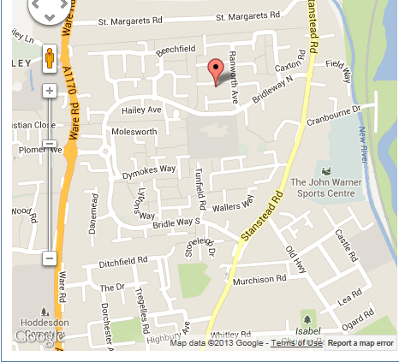

PREGNANCY YOGA FORM

Anne Coleman’s Pregnancy Yoga
(77 Ranworth Ave, Hoddesdon, Herts, EN11 9NS)

Start date: _______________________________________

Name: _______________________________________________

Address _______________________________________________

_______________________________________________

_______________________________________________

Post Code: _______________________________________________

Telephone No.: _______________________________________________

e-mail: _______________________________________________

______ (*) I would / would not like to receive copies of any relevant handouts to this email address and (*) I give / do not give permission for other members of the yoga groups to know my email address (* please delete as applicable)

Medical history ______________________________________

Due Date ____________________________________

I declare that the information have given above is correct. I understand that I enter into an exercise programme entirely at my own risk and waive any legal recourse for damages that may arise from my participation.

Signature ……………………………. Date …………………

